**EUROPEAN SOCCER DATABASE ANALYSIS WITH SQL**

**Alessandro Bernaudo**

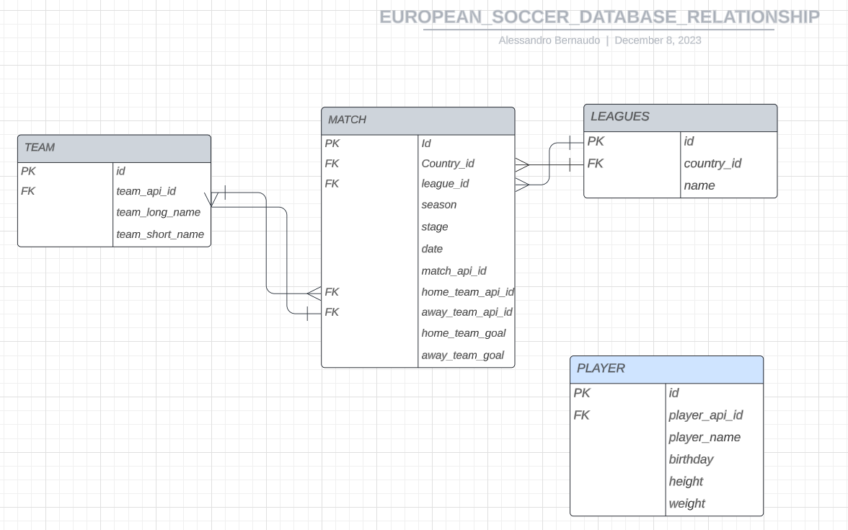

I wanted to know How many days have passed from the oldest match to the most recent one.

with a as

(SELECT distinct first_value(date)over(order by date) as firstmatch_date,

(select distinct first_value(date)over(order by date desc) FROM `sql-project-1-398317.EUROPEAN_SOCCER_DATABASE.match`) as lastmatch_date

FROM `sql-project-1-398317.EUROPEAN_SOCCER_DATABASE.match`)

select firstmatch_date, lastmatch_date,

date_diff(lastmatch_date, firstmatch_date, day) as days_from_first_to_last_match

from a;



I produced a table which, for each Season and League Name, shows the following statistics about the home goals scored:

min, average , mid-range ,max ,sum

with x as(

  select

a.*, b.name

from `sql-project-1-398317.EUROPEAN_SOCCER_DATABASE.match` as a

left join

`sql-project-1-398317.EUROPEAN_SOCCER_DATABASE.leagues` as b

on a.league_id=b.id

)

select

distinct season,

name,

first_value(home_team_goal) over(partition by season, name order by home_team_goal ) as  min_home_gol,

round(avg(home_team_goal) over(partition by season, name ),2) as avg_home_gol,

first_value(home_team_goal) over(partition by season, name order by home_team_goal desc) as max_home_gol,

sum(home_team_goal) over(partition by season, name) as sum_home_gol,

(((first_value(home_team_goal) over(partition by season, name order by home_team_goal desc))+(first_value(home_team_goal) over(partition by season, name order by home_team_goal )))/2) as mid_range

from x

order by name, season;

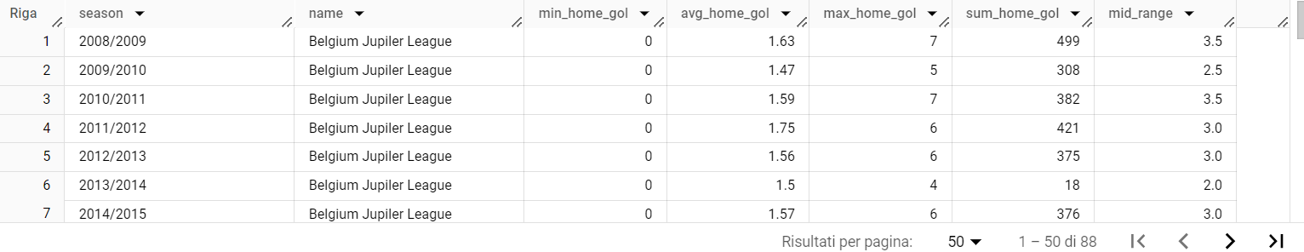

I Found out how many unique seasons are in the Match table.

select count(season) as nr_unique_seasons

from(select distinct season, league_id from `sql-project-1-398317.EUROPEAN_SOCCER_DATABASE.match`);

I wrote a query that shows, for each Season, the number of matches played by each League.

with x as

  (select

a.*, b.name

from `sql-project-1-398317.EUROPEAN_SOCCER_DATABASE.match` as a

left join

`sql-project-1-398317.EUROPEAN_SOCCER_DATABASE.leagues` as b

on a.league_id=b.id)

select

distinct season,

name,

count(*) over(partition by season, name)

from x

order by name, season;

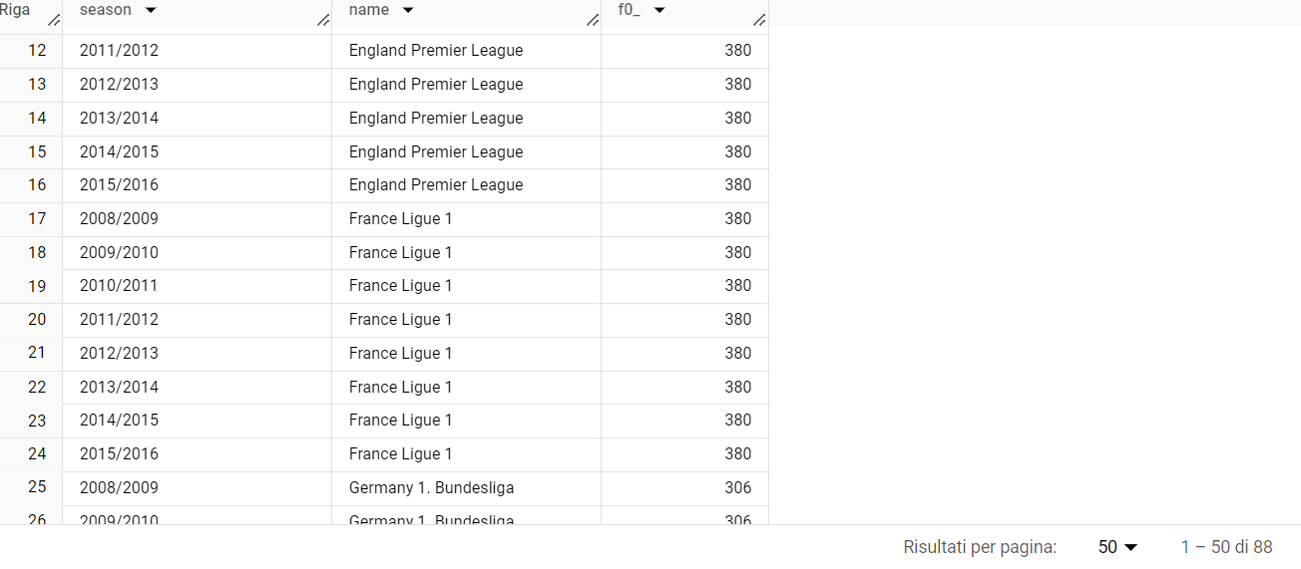

Using Players as the starting point, I created a new table (PlayerBMI) adding the following variables:

a. a new variable that represents the players’ weight in kg and called it kg_weight;

b. a variable that represents the height in meters and called it m_height;

c. a variable that shows the body mass index (BMI) of the player;

create table `sql-project-1-398317.EUROPEAN_SOCCER_DATABASE.playerBMI` AS

(select *,

round(weight/2.205,2) as kg_weight,

round(height/100,2) as m_height,

round((weight/2.205)/(power(height/100, 2)),2) as BMI

from `sql-project-1-398317.EUROPEAN_SOCCER_DATABASE.player`);

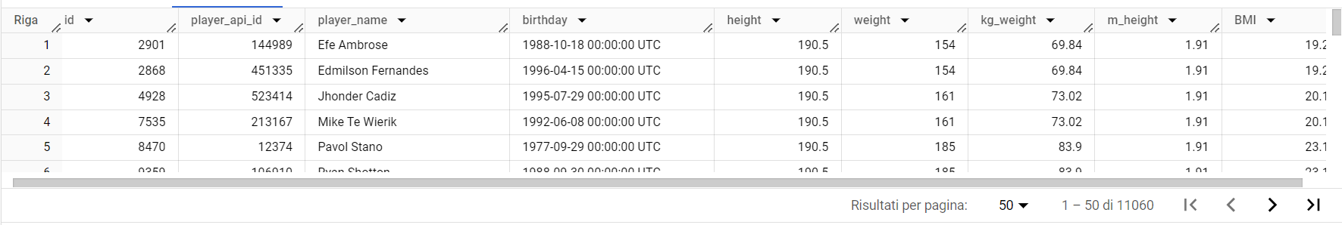

I filtered the table to see the nr of players with not optimal BMI

Select

count(*) as nr_player_with_bad_bmi

from `sql-project-1-398317.EUROPEAN_SOCCER_DATABASE.playerBMI`

where BMI<18.5 or BMI>24.9;

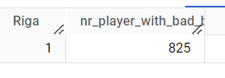

I wanted to know which Team scored the highest total number of goals (home + away) during the most recent available season and how many goals it has scored

select

a.team_api_id, a.team_long_name,

sum(case when b.home_team_api_id=a.team_api_id then b.home_team_goal end) as tot_home_goal,

sum(case when b.away_team_api_id=a.team_api_id then b.away_team_goal end) as tot_away_goal,

((sum(case when b.home_team_api_id=a.team_api_id then b.home_team_goal end))+

(sum(case when b.away_team_api_id=a.team_api_id then b.away_team_goal end))) as tot_goal

from `sql-project-1-398317.EUROPEAN_SOCCER_DATABASE.team` as a

left join

`sql-project-1-398317.EUROPEAN_SOCCER_DATABASE.match` as b

on a.team_api_id=b.home_team_api_id or a.team_api_id=b.away_team_api_id

where season="2015/2016"

group by a.team_api_id, a.team_long_name

order by tot_goal desc;

I created a query that, for each season, shows the name of the team that ranks first in terms of total goals scored

with x as

(select

b.season, a.team_api_id, a.team_long_name,

sum(case when b.home_team_api_id=a.team_api_id then b.home_team_goal end) as tot_home_goal,

sum(case when b.away_team_api_id=a.team_api_id then b.away_team_goal end) as tot_away_goal,

((sum(case when b.home_team_api_id=a.team_api_id then b.home_team_goal end))+

(sum(case when b.away_team_api_id=a.team_api_id then b.away_team_goal end))) as tot_goal,

rank() over(partition by b.season order by ((sum(case when b.home_team_api_id=a.team_api_id then b.home_team_goal end))+

(sum(case when b.away_team_api_id=a.team_api_id then b.away_team_goal end)))desc) as rank

from `sql-project-1-398317.EUROPEAN_SOCCER_DATABASE.team` as a

left join

`sql-project-1-398317.EUROPEAN_SOCCER_DATABASE.match` as b

on a.team_api_id=b.home_team_api_id or a.team_api_id=b.away_team_api_id

group by b.season, a.team_api_id, a.team_long_name

)

select*

from x

where rank=1

order by season;

Finally I created a new table (TopScorer) containing the top 10 teams in terms of total goals scored

create table `sql-project-1-398317.EUROPEAN_SOCCER_DATABASE.TopScorer` as

(select

a.team_api_id, a.team_long_name,

sum(case when b.home_team_api_id=a.team_api_id then b.home_team_goal end) as tot_home_goal,

sum(case when b.away_team_api_id=a.team_api_id then b.away_team_goal end) as tot_away_goal,

((sum(case when b.home_team_api_id=a.team_api_id then b.home_team_goal end))+

(sum(case when b.away_team_api_id=a.team_api_id then b.away_team_goal end))) as tot_goal

from `sql-project-1-398317.EUROPEAN_SOCCER_DATABASE.team` as a

left join

`sql-project-1-398317.EUROPEAN_SOCCER_DATABASE.match` as b

on a.team_api_id=b.home_team_api_id or a.team_api_id=b.away_team_api_id

where season="2015/2016"

group by a.team_api_id, a.team_long_name

order by tot_goal desc

limit 10);

